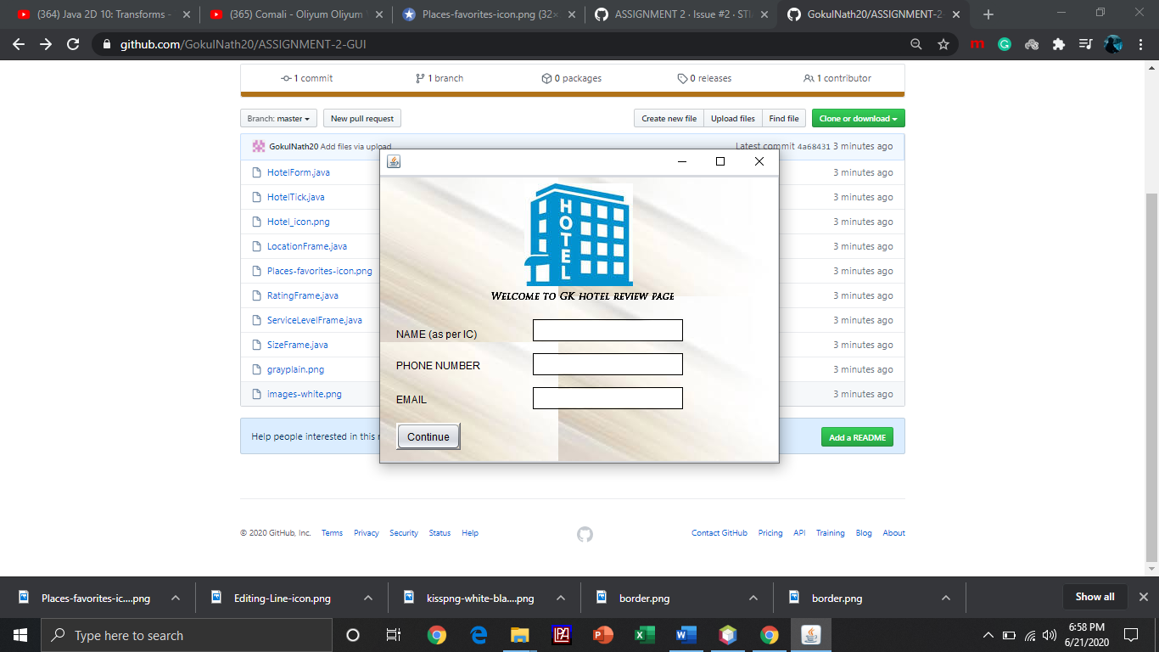

1. User must insert name, phone number and email address.
2. And then press “continue” to proceed.

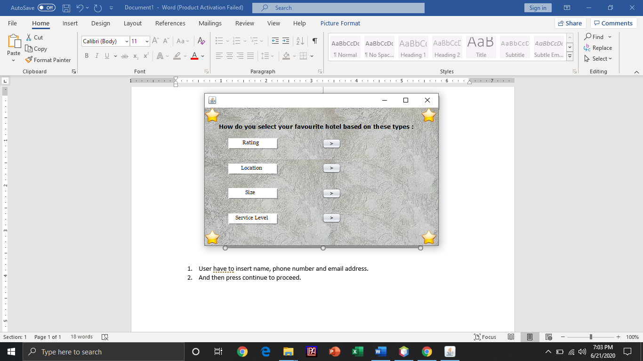

1. After that user must choose favorite hotel based on given types.

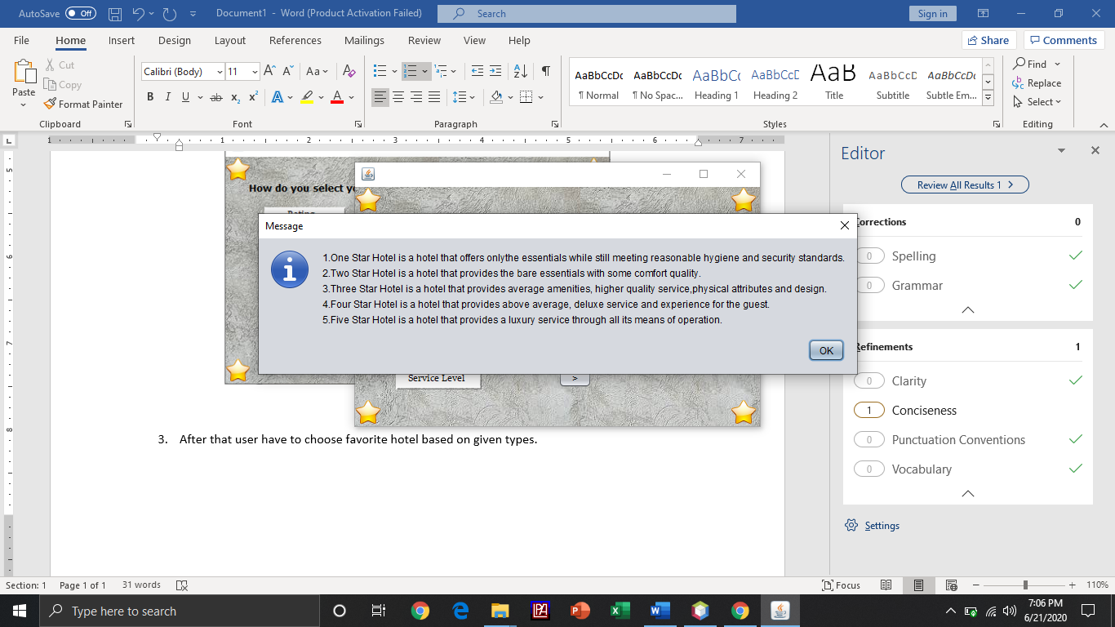

1. For example, if the user chooses the rating option, the information regarding the hotel types based on rating will be displayed.
2. And then user must click “ok”.

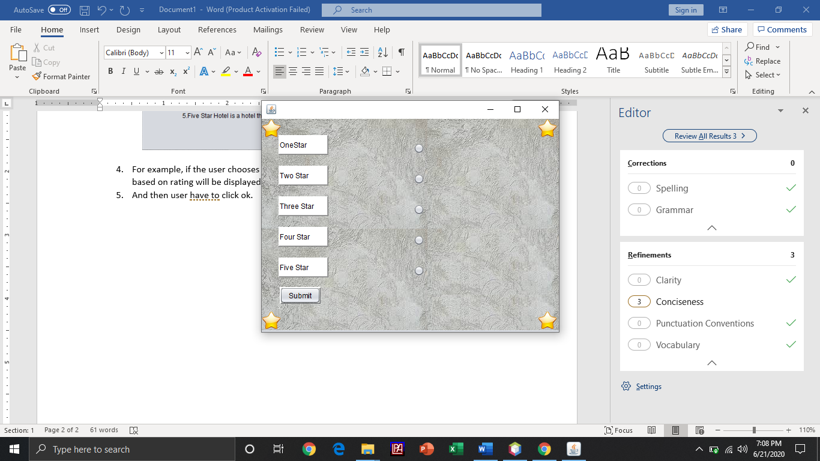

1. After user understands about the hotel types, he/she must choose the hotel type based on given types.
2. For example, if rating the types are, one star,two star,three star and etc.
3. Finally, user must click “submit” button.

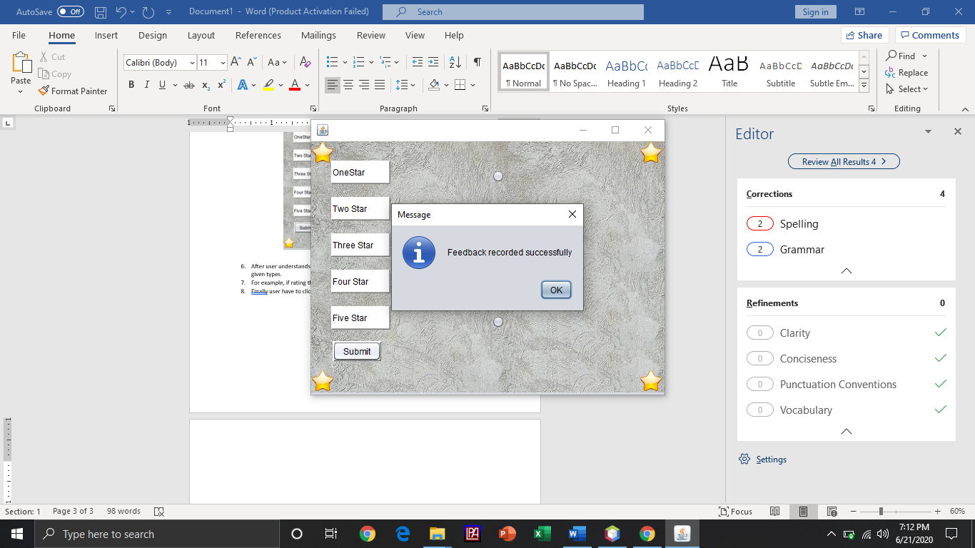

1. And then “feedback recorded successfully message will be displayed”.
2. User must click “ok” to exit the program.
3. The program ends.